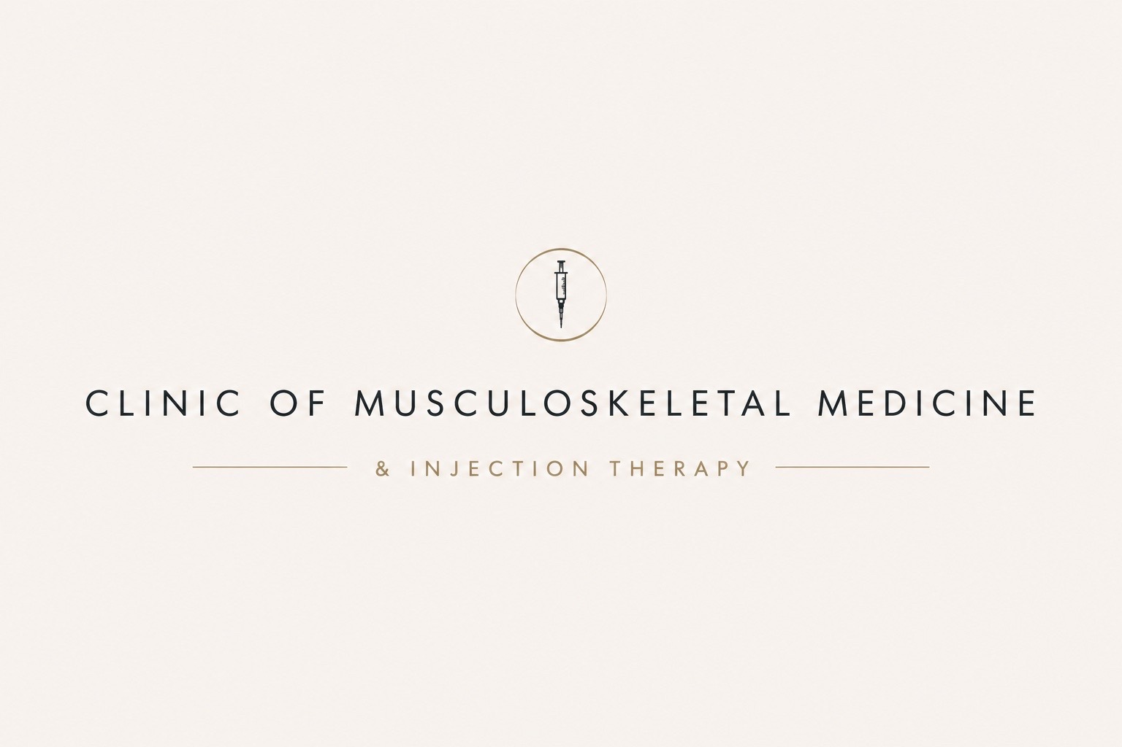
YOUR CORTICOSTEROID INJECTION APPOINTMENT
Appointment information & pre-injection patient guidance
PATIENT
APPOINTMENT
TREATMENT | Corticosteroid injection
LOCATION | Park View Medical Clinic, 276 Marton Road, Middlesbrough, TS4 2NS

Before your appointment
- Please read this information before attending. Your clinician will review your condition, confirm that an injection is appropriate and discuss consent with you before any procedure takes place.
- You can eat and drink normally and take your usual medicines unless you have specifically been advised otherwise. Wear clothing that allows easy access to the area being assessed.
- Please bring an up-to-date medication list if your medicines have changed or are not already known to the clinic.
- Please contact the clinic before attending if you become unwell, develop a fever or infection, start antibiotics, or develop broken/infected skin near the proposed injection site.
- Please tell the clinic if you take anticoagulant or antiplatelet medicines (for example warfarin, apixaban, rivaroxaban, dabigatran, edoxaban, clopidogrel or aspirin). Do not stop these medicines yourself unless specifically advised by the clinician who manages them.
- Please tell your clinician if you have diabetes, are pregnant or breastfeeding, have had a previous reaction to steroid or local anaesthetic, or have recently had/planned surgery or vaccination.

What is a corticosteroid injection?
Corticosteroids are anti-inflammatory medicines. A small amount can be injected into or around a painful joint or soft-tissue structure to reduce inflammation and pain. A local anaesthetic may also be used, depending on the injection and your individual circumstances.
The injection is intended to reduce symptoms and help you move and rehabilitate more effectively. It does not cure the underlying condition, and benefit cannot be guaranteed.

What benefit can I expect?
Response varies according to the condition and injection site. Some people notice improvement within a few days, while others take longer. Relief may be temporary and symptoms can recur.
For osteoarthritis specifically, NICE recommends considering intra-articular corticosteroid injections when other pharmacological treatments are ineffective or unsuitable, or to support therapeutic exercise, and advises that the expected benefit is short term - approximately 2 to 10 weeks.

What happens at the appointment?
- Your clinician will review your symptoms, diagnosis, medical history, medicines and suitability for injection.
- The expected benefits, alternatives, limitations and material risks will be discussed and you will have the opportunity to ask questions.
- Consent will be confirmed before proceeding.
- The skin will be cleaned using an antiseptic technique and the corticosteroid will be injected into the agreed area. Local anaesthetic may also be used.
- A small dressing or plaster may be applied and you will receive post-injection advice before leaving.

CORTICOSTEROID INJECTION - RISKS & PRACTICAL INFORMATION

Possible side effects and risks
- Temporary pain or a 'post-injection flare'. Symptoms can be more painful for around 24-48 hours before settling.
- Bruising or bleeding around the injection site, particularly if you take blood-thinning medication.
- Temporary facial flushing or dizziness.
- Skin colour change and/or thinning or loss of fat beneath the skin at the injection site. These changes can occasionally persist.
- A temporary rise in blood glucose. This is particularly relevant if you have diabetes.
- Menstrual disturbance or vaginal bleeding can occur.
- Allergic reaction to the corticosteroid, local anaesthetic or another product constituent is uncommon but can be serious.
- Infection is rare but potentially serious.
- Where injections are given in or around tendons, corticosteroid can weaken tendon tissue and tendon rupture is a recognised risk.
- Repeated corticosteroid injections may increase the risk of local tissue, cartilage or tendon damage. Any repeat injection will therefore be considered individually.
Important - contact the clinic before attending
If you have an active infection, are taking antibiotics, feel feverish or acutely unwell, have broken/infected skin around the planned injection site, have poorly controlled diabetes, have had a significant medication change, or there has been a change in your health that may affect the procedure.

Diabetes
Steroid injections can temporarily increase blood glucose, most noticeably during the first few days. If you have diabetes, your clinician will discuss this with you. You should be able to monitor your glucose appropriately after the injection and know how to obtain advice if it becomes unusually high or difficult to control.

Blood-thinning medication
Being prescribed an anticoagulant or antiplatelet medicine does not automatically mean you cannot have an injection, but the bleeding risk and injection site need to be considered. Please ensure your clinician knows exactly which medicine you take. Do not omit or stop prescribed anticoagulant/antiplatelet medication unless you have been specifically instructed to do so.

Vaccination, surgery and other treatment
Please tell your clinician about recent or planned vaccinations, surgery, other steroid treatment or significant medical treatment. Whether timing needs to be altered depends on the vaccine/procedure, steroid preparation and your individual clinical circumstances; there is not one universal interval that applies to every patient.

Driving and getting home
Most people do not routinely need someone to drive them home after a straightforward peripheral MSK injection. However, the injected area may be sore or temporarily numb if local anaesthetic is used. You should not drive if pain, numbness, weakness or reduced movement means you cannot safely control a vehicle.

After the injection
You will be given separate post-injection guidance. In general, relative rest of the treated area is advised initially, followed by a gradual return to normal activity and rehabilitation according to comfort and the advice provided by your clinician.
Seek urgent medical advice after an injection
If you develop rapidly increasing or severe pain, marked swelling, redness or heat around the injection site, fever/chills or feel systemically unwell, seek urgent medical assessment and tell the clinician that you have recently had a corticosteroid injection.

Questions or appointment changes
If you have any questions about the proposed injection, or your health changes before the appointment, please contact the clinic before attending.
www.clinicofmskmedicine.co.uk
Please keep this information for reference after your appointment.
Patient information version 1.0 | September 2026 | Review September 2027 or sooner if clinical guidance changes

