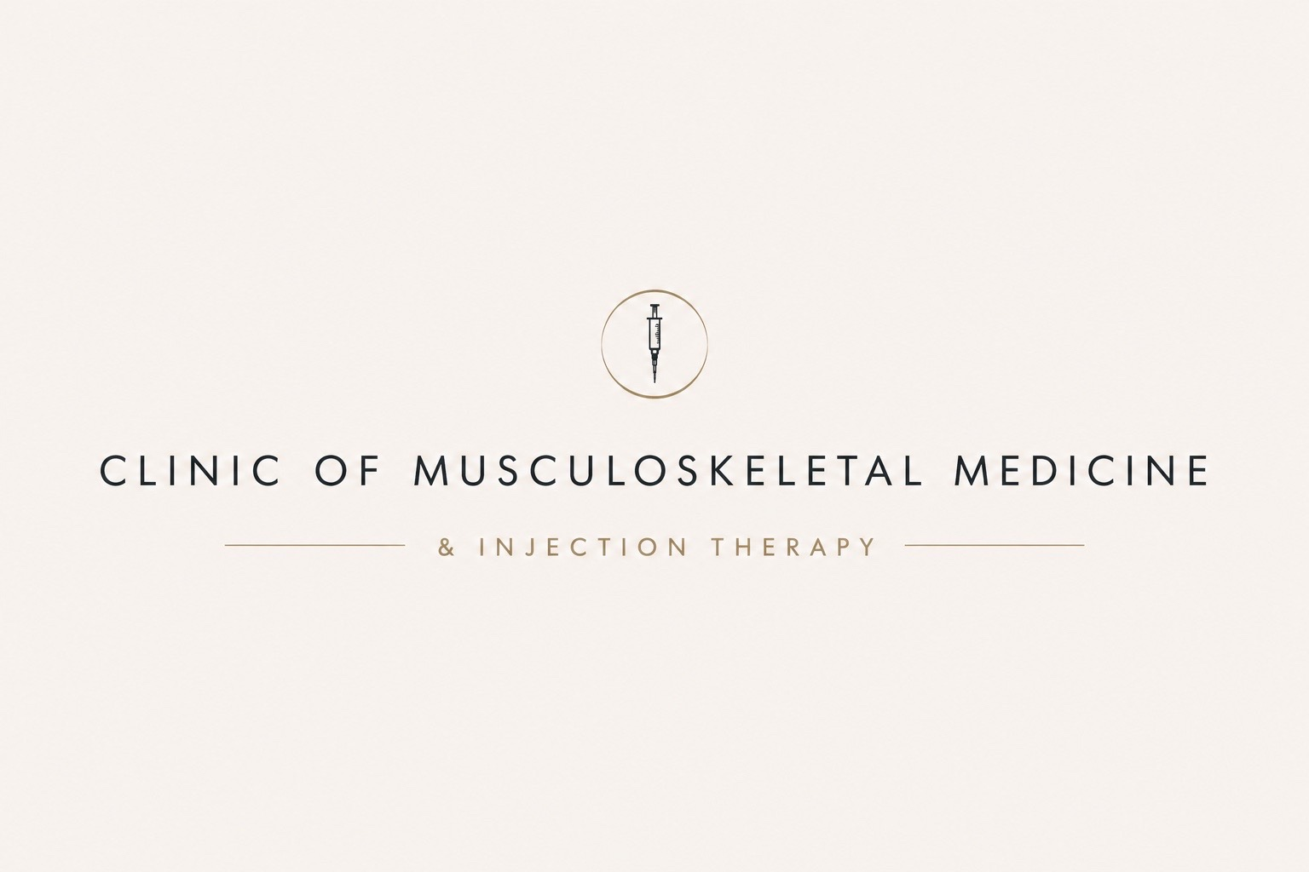
AFTER YOUR CORTICOSTEROID INJECTION
Post-injection patient guidance
Your injection has now been completed.
Please keep this information and follow the advice below. Individual advice given by your clinician takes priority where it differs from this general guidance.

INJECTION SITE / SIDE | ________________________________________
DATE | ________________________

For the rest of today
- Keep the injection site clean and avoid rubbing or repeatedly touching it.
- Relative rest is sensible for the injected area for the remainder of the day. Gentle normal movement is usually fine.
- Avoid strenuous exercise, heavy loading or high-impact activity involving the treated area for around 24-48 hours, then gradually return according to comfort and the advice you were given.
- If a dressing or plaster was applied, it can usually be removed later the same day once the puncture site is dry.

What you may notice
- The local anaesthetic, if used, may make the area feel better for a few hours before wearing off.
- A temporary increase in pain ('post-injection flare') can occur during the first 24-48 hours. Simple pain relief can be used if it is normally safe for you.
- The steroid does not always work immediately. Improvement may begin over several days; the amount and duration of benefit vary between people.
- Temporary facial flushing can occur. Bruising or local tenderness around the injection site may also occur.

If you have diabetes
- Corticosteroid injections can temporarily raise blood glucose. Monitor your glucose more frequently for the next few days in accordance with your usual diabetes plan and seek clinical advice if readings become unusually high or difficult to control.

Returning to exercise and rehabilitation
- Once the initial post-injection period has settled, gradually resume your rehabilitation/exercise programme. The aim of an injection is usually to create an opportunity to improve movement, strength and function rather than to replace rehabilitation.
- Follow any condition-specific restrictions or return-to-sport advice given to you by your clinician.

When to seek urgent medical advice
Please seek urgent medical assessment if you develop rapidly increasing or severe pain, marked swelling, increasing redness or heat around the injected area, fever, chills, or you feel systemically unwell. These can be signs of infection and should not be assumed to be a normal post-injection flare.

Questions or concerns
If you have a non-urgent concern about your injection or recovery, please contact the clinic. If you are acutely unwell or cannot contact the clinic, use NHS 111 or the appropriate urgent/emergency service.
Patient aftercare guidance | Corticosteroid injection | Version 1.0 | September 2026

